
A12
Sreenidhi Institute of Science and Technology
(An Autonomous Institution)
Code No: 3C307
B. TECH. II-Year I-Semester Examinations, December 2015 (Supplementary)
ELECTRONIC CIRCUIT ANALYSIS (ECE)

Time: 3 Hours Max. Marks: 70

Note: No additional answer sheets will be provided.

Part - A
Max.Marks:20

Answer all QUESTIONS. EACH QUESTION CARRIES 2 MARKS.
1. | Draw the Hybrid-π model of Common Emitter amplifier.
2. | Give the expressions of Z_{i} and Z_{o} for Voltage Shunt feedback.
3. | Classify the Power amplifiers based on their angle of conduction.
4. | What are the applications of tuned amplifiers?
5. | List out the characteristics of Common Drain Amplifier.
6. | Draw the circuit of Voltage doubler and Voltage Tripler.
7. | Draw any two circuits having high input resistance.
8. | What is a double tuned amplifier?
9. | List out the various techniques used for biasing the E-MOSFET and D-MOSFET.
10. | Explicate the Barkhausen stability criterion for Oscillators.

Part – B
Max.Marks:50

ANSWER ANY FIVE QUESTIONS. EACH QUESTION CARRIES 10 MARKS.
1. | a) | Draw the circuit diagram of single stage RC-Coupled BJT amplifier. Discuss the effect of Emitter bypass Capacitor on Low-Frequency Response. |  | 5 Marks
 | b) | Explicate the different methods of coupling used in Multistage amplifiers with respect to frequency response. |  | 5 Marks
2. | a) | Explicate the effect of negative feedback on amplifier characteristics. |  | 4 Marks
 | b) | Develop an expression for frequency of oscillations for RC-phase shift oscillator. |  | 6 Marks
3. | a) | Derive the expressions for theoretical efficiency of Transformer coupled amplifiers. |  | 5 Marks
 | b) | Explain about Class D and Class S power amplifiers. Mention their salient features and applications. |  | 5 Marks
4. | a) | What is meant by stagger tuning in tuned amplifiers and list out the applications of tuned amplifiers? |  | 5 Marks
 | b) | Explicate the operation of CE – Double tuned amplifier and sketch the frequency response. |  | 5 Marks
5. | a) | For the n-channel depletion-type MOSFET of Fig., determine:  (a) I_{DQ} and VG_{SQ}. (b) V_{DS}.  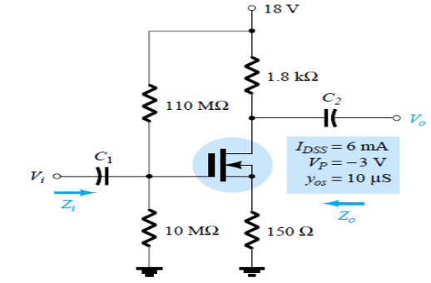 |  | 5 Marks
 | b) | Using the above results, for the above circuit shown in fig.,  (a) Determine g_{m} and compare to g_{m0}.  (b) Find rd.  (c) Sketch the ac equivalent network.  (d) Find Zi.  (e) Calculate Zo.  (f ) Find Av. |  | 5 Marks
6. | a) | Draw the circuit for 7805 Voltage Regulator IC and explain its working. |  | 5 Marks
 | b) | Define the terms  - Load Regulation  - Line Regulation | - Ripple Rejection  - Sense Voltage  - Temperature stability pertaining to Voltage Regulator ICs. | 5 Marks
7. |  | Draw the circuit for Cascode amplifier, explain its working and derive the expressions for A_{V}, A_{I}, Z_{I}, Z_{O.} |  | 10 Marks
8. | a) | Design a + 12 V voltage regulator circuit using 723 IC to give current limit of 50 mA. |  | 5 Marks
 | b) | Using 7805C, voltage regulator, design a current source that will deliver a 0.25 A current to the 48 Ω-10 W load. |  | 5 Marks

-- 00 -- 00 –

